|  |  |  |  |
| --- | --- | --- | --- |
| Umutwe w'ikina mashusho | **Ant's Proble** | |  |
| Ingingo | Problem solving | |  |
| Intego | Finding out how a change in perspective can turn a difficult problem into an easy one. | |  |
| Uburebure | 45min | |  |
| Aho ihuriro(camp) niherereye |  | |  |
| Abafashamyumvire |  | |  |
| Umubare. w'abanyeshuri |  | |  |
| Itariki |  | |  |
| Ibikoresho  nkenerwa | Pen and Paper | |  |
| Imyiteguro | None | |  |
|  | | | |
| **Igihe cy'ikinamashusho** | **Ibyo umufashamyumvire akora** | **Ibyo abanyeshuri bakora** | |
| 00:00 - 00:26 | Intangiriro rusange y'ikinamashusho ya VMC | |  |
| 00:27 – 01:08 | Intangiriro y' ikinamashusho | |  |
| 01:09 – 02:27 | Riddle | |  |
| VIDEO PAUSE Solve the first version of the riddle | * Assist the process, provoke thoughts * When a learner suggests a possible starting situation, ask if he/she is able to show that no other possible initial setting is better or equal. | * Learners will try different initial settings to figure out the possible solutions | |
| 02:28 – 3:10 | 3 Ants version | |  |
| VIDEO PAUSE Solve the second version | * Assist the process, provoke thoughts * When a learner suggests a possible starting situation, ask if he/she is able to show that no other possible initial setting is better or equal. | * Learners will try different initial settings to figure out the possible solutions | |

Igisubizo

This problem is about a change in perspective:

Imagine the same problem but with a single difference in the statement: the ants do not bounce and change verse when they collide, but rather walk on top of each other and keep on moving as if nothing happened.

If you think about this second statement, you will notice that the problem is not really changing:

If you watch points move on a segment, it is impossible to distinguish between bouncing points and surpassing points.

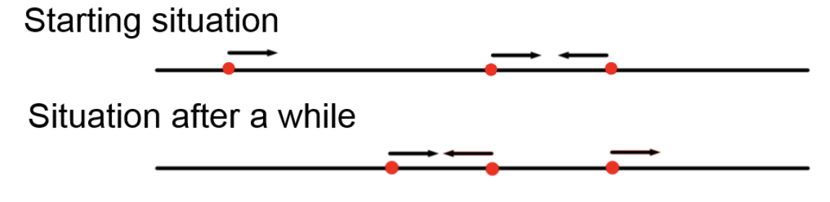

Are you able to tell if the image above was created thinking about bouncing ants or surpassing ants?

If you look closely you will realize that it is impossible to tell.

This:

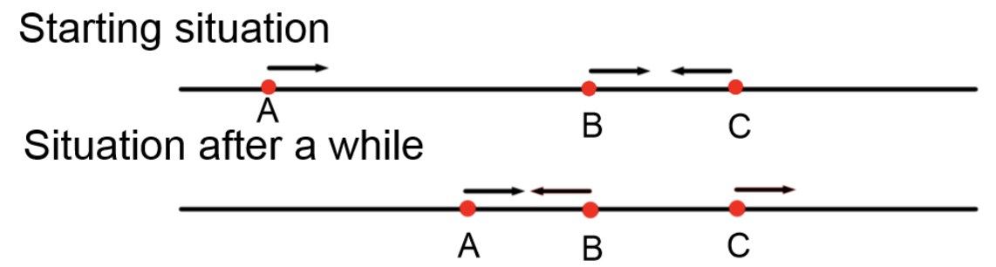

and this:

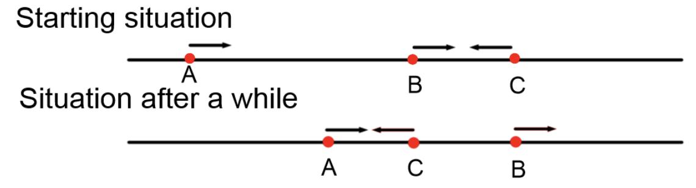

Are indistinguishable unless you name the ants ( A,B and C in the example)

BUT

By just having a different way of stating the same problem, finding the solution is now easy:

Each ant will walk straight until it falls from one edge. Meaning that every initial position of the ants (no matter how many ants) will last the most if one ant starts from an edge walking towards the other edge.

If you think about surpassing ants this means that the ant that starts the furthest away from the edge, is the last one to fall.

If you think about bouncing ants, you still don’t know which specific ant will be the last to fall, but if an ant starts from the edge you know that there exists an ant that will fall after 1 meter of walk.

So, it doesn’t matter how many ants are on the cliff or how they are positioned at the start, as long as one ant is starting from the edge facing the other edge.